NORTH BOLIVAR CONSOLIDATED SCHOOL DISTRICT
204 North Edwards Avenue
Mound Bayou, MS 38762

Regular Meeting Minutes
NBCSD Library
December 21, 2020 | 11:00 am

Board Members Present Board Member(s) Absent
Jefferick Butler, Chairman Lashonda Walker, Member Tyrone Miller, Vice-Chairman
William Lucas, Member
Jacquelyn Allen, Secretary

OTHER INDIVIDUALS PRESENT
Kenyatta McClain Fredrick Ford Addie Miller
Maurice Smith Doris Hall

- CALL TO ORDER/INVOCATION
At 6:00 p.m., the regular board meeting of the North Bolivar Consolidated School District convened on December 21, 2020 in the Library at North Bolivar Consolidated School District, 204 North Edwards Avenue, Mound Bayou, Mississippi 38762. Board Chairman Jefferick Butler called the meeting to order, and Tyrone Miller offered invocation.

- ADOPTION OF THE AGENDA
The Board voted to adopt the agenda as presented. Mrs. Jacquelyn Allen motioned and Mr. Tyrone Miller seconded. Mr. William Lucas, Mrs. Jacquelyn Allen, Mr. Tyrone Miller, and Chairman Jefferick Butler all voted aye. No one cast against the motion. PASSED

- APPROVAL OF THE MINUTES FROM November 16, 2020 Regular Board Meeting and November 23, 2020 Called Board Meeting
The Board voted to table item 3 until the next Board Meeting. Mrs. Jacquelyn Allen motioned and Mr. Tyrone Miller seconded. Mrs. Jacquelyn Allen, Mr. Tyrone Miller, Mr. William Lucas, and Chairman Jefferick Butler all voted aye. No one cast against the motion. PASSED

- SUPERINTENDENT'S REPORT
The Superintendent stated that there were two new thing to report on. Northside High received the furniture in the lab. The district received all electronic devices and distributed them. The Board voted to receive the superintendent’s report. Mrs. Jacquelyn Allen motioned and Mr. Tyrone Miller seconded. Mrs. Jacquelyn Allen, Mr. Tyrone Miller, Mr. William Lucas, and Chairman Jefferick Butler all voted aye. No one cast against the motion. PASSED

- CELEBRATION AND ACKNOWLEDGEMENT
The Superintendent acknowledged the district received reimbursement from HB1788 MS Pandemic Response Broadband Availability and Equity in Distance Learning Act (EDLA).
- PRINCIPAL’S REPORT
I.T. Montgomery Elementary, Mrs. Addie Miller
Brooks Elementary, Mrs. Doris Hall
Northside High, Mr. Fredrick Ford
Each Principal discussed goal one and benchmark accountability estimate. Board voted to receive the principal’s report. Mrs. Jacquelyn Allen motioned and Mr. Tyrone Miller seconded. Mrs. Jacquelyn Allen, Mr. Tyrone Miller, Mr. William Lucas, and Chairman Jefferick Butler all voted aye. No one cast against the motion. PASSED

- DISCUSSION/ACTION
  - Review of the Superintendent’s recommendation to declare the property located at: 201 Green Street, Mound Bayou, MS 38762 and 700 Lauderdale Street, Shelby, MS 38774 not being used and is no longer needed in the operation of the schools of the district and would like to dispose of said property in accordance with Mississippi Code 37-7-455.
  - Return of Superintendent's Evaluation to be discussed at January Meeting
Board voted to table item 7.1 property located at 201 Green Street Mound Bayou, MS 38762. Board voted to sale the property at 700 Lauderdale Street, Shelby, MS 38774 individually, which consist of two lots one lot with a house and the other a lot by itself. The board voted to approve item 7.2. Mr. Tyrone Miller motioned and Mrs. Jacquelyn Allen seconded. Mrs. Jacquelyn Allen, Mr. Tyrone Miller, Mr. William Lucas, and Chairman Jefferick Butler all voted aye. No one cast against the motion. PASSED

- CONSENT AGENDA
  - Approval of Superintendent's recommendation to accept a used vehicle from the Bolivar County Board of Supervisor and Sheriff Kevin Williams.
It was motioned by Mr. Tyrone Miller and seconded by Mrs. Jacquelyn Allen to approve item 8.1 under the Consent Agenda. Mr. Tyrone Miller, Mrs. Jacquelyn Allen, and Chairman Jefferick Butler, Mr. William Lucas, and all voted aye. No one voted against the motion. PASSED

- FINANCIAL REPORTS
  - Claim Docket
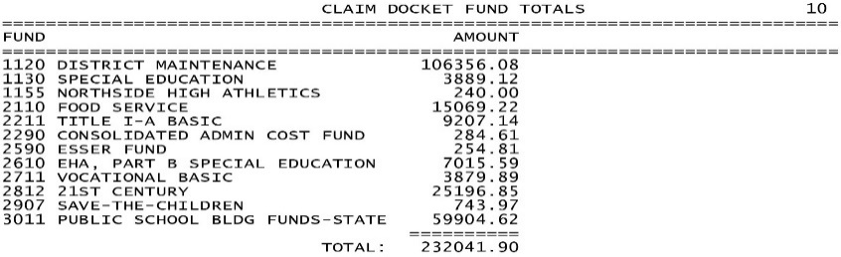

  - Activity Reports
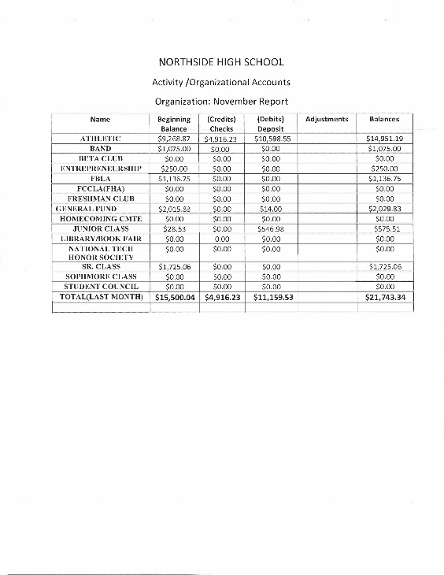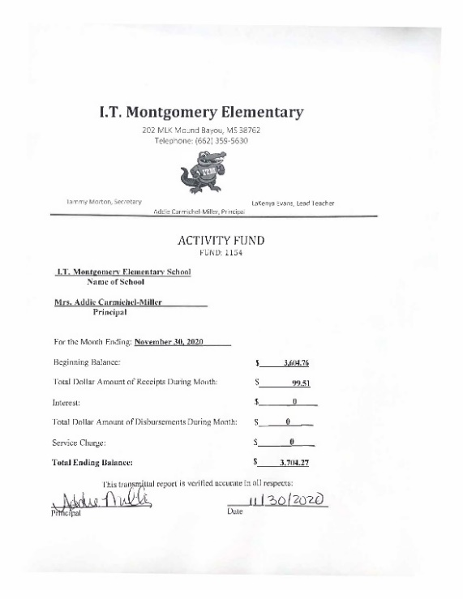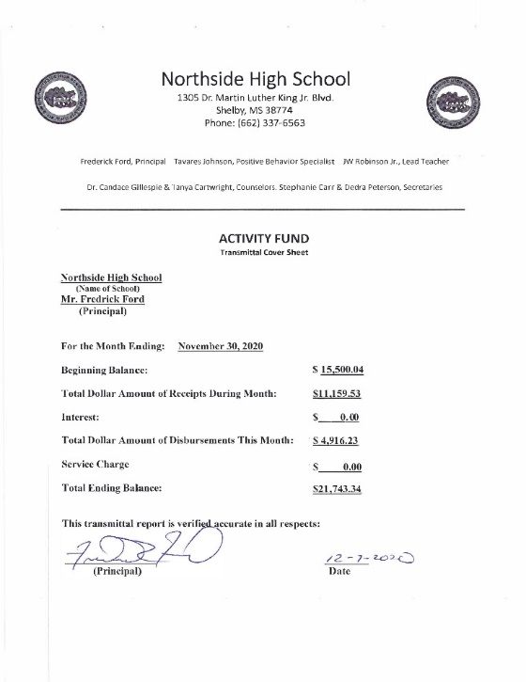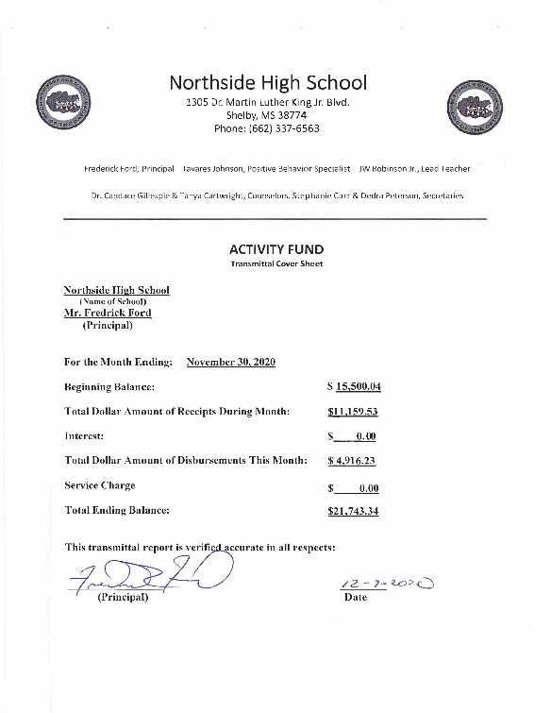

  - Financial Reports
It was motioned by Mr. Tyrone Miller and seconded by Mrs. Jacquelyn Allen to approve all items under the Financial Report. Mr. Tyrone Miller, Mrs. Jacquelyn Allen and Chairman Jefferick Butler voted aye. Mr. William Lucas voted against the motion. PASSED
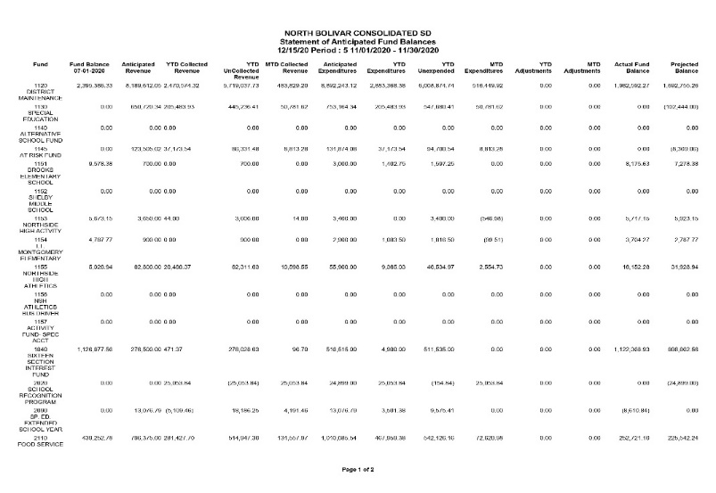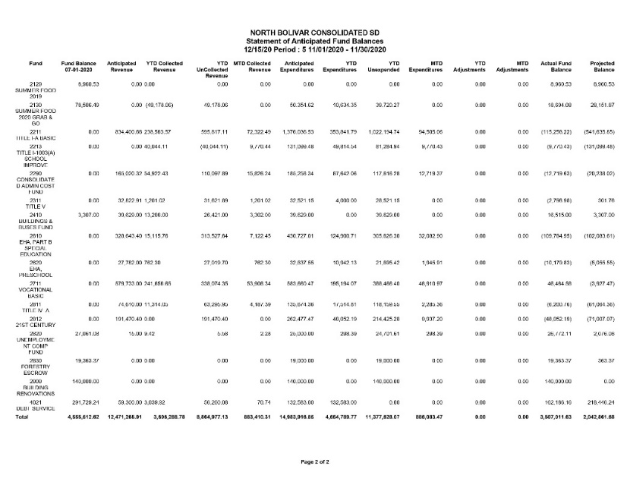

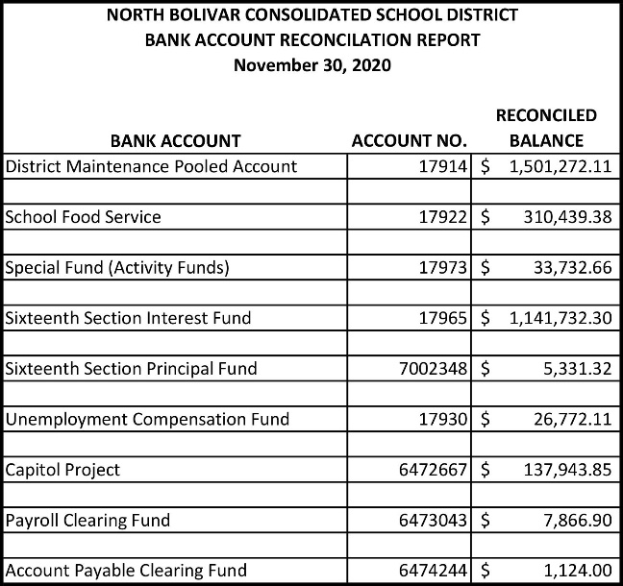

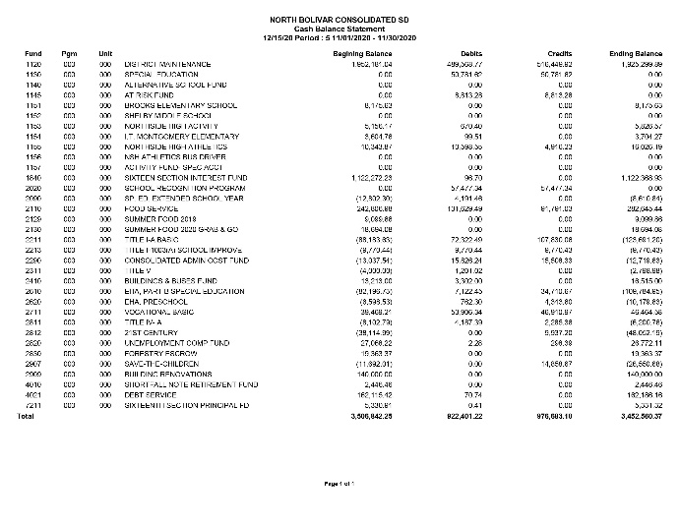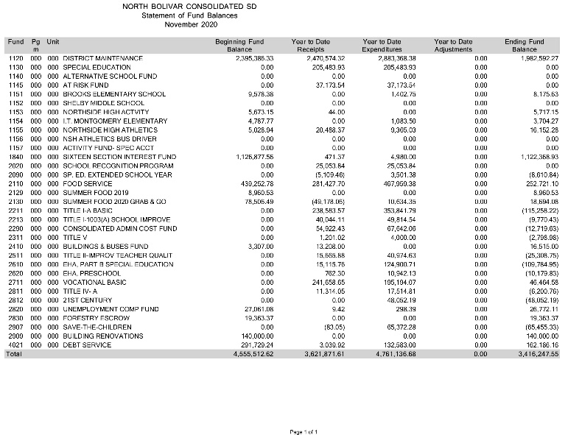

- ADJOURNMENT
The Superintendent will let the date of the board meeting for January 2021 since the third Monday is on MLK Holiday. There were no further actions or discussions, it was moved by Mr. Mrs. Jacquelyn Allen and seconded by Mr. Tyrone Miller to adjourn. Chairman Jefferick Butler, Mr. Tyrone Miller, Ms. Jacquelyn Allen, and Mr. William Lucas all voted aye. There were no nays. PASSED
Board meeting adjourned at 11:44 am.

Attest: Approved:

________________________________ ________________________________
Secretary President

